DRONE FLIGHT LOCATIONS – (FULL NAME), (DATE FROM-TO)
 |  |  | For Office Use
Spot  Nr. | GPS-  Co-ordinates | Map Screenshot | FUA | ATC | MET
1 | 19°43'49"S  14° 18'12"E  SAMPLE CO-ORDS  MUST BE DEG, MIN, SEC  Date :  4-5/6/2019  The height of the flight will not be above 150ft | 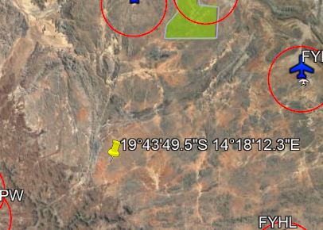  SAMPLE MAP – PLEASE USE KMZ!
2 | 20°39'14.2"S 14°34'00.8"E  SAMPLE CO-ORDS  MUST BE DEG, MIN, SEC  Date :  5-6/6/2019  The height of the flight will not be above 150ft | 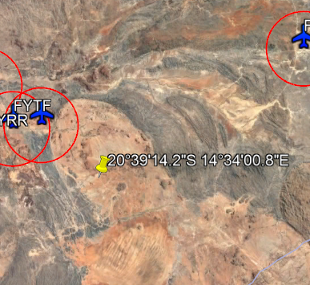  SAMPLE MAP – PLEASE USE KMZ!
3
4
5

